Machine learning
Machine learning is a field of computer science that uses Statistical Techniques to give computer systems the ability to learn with data without being explicitly programmed.
Example- Email Spam identifier , image classification etc.
There are four types of machine learning:-
1.Supervised machine learning
- Regression
- Classification
2.Unsupervised machine learning
- Clustering
- Dimensionality reduction
- Anomaly detection
- Association
3.Semi-supervised
4.Reinforcement
There are two types of training paradigms in machine learning:-
1.Batch machine learning
Batch is a traditional way of training our ML model. We have full data together to train our ml model. There is no incremental training. Once the model is trained then we deploy it.
Problem: if it is trained once then it will not learn new things according to the new data e.g. Netflix server:movies are uploaded every month as new data.
2.Online machine learning
Online machine learning is done incrementally that means the ML training is done in small batches after every batch training ML model gets better and better
E.g. Youtube , chatbots etc.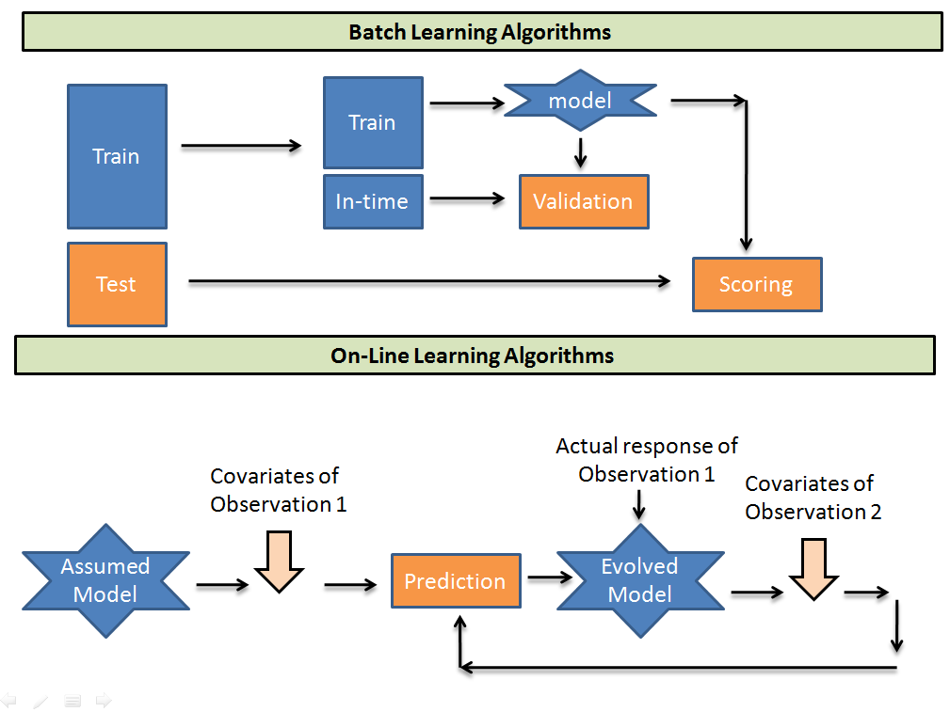
Figure 1.1
SVM-Support vector machine
It is a supervised machine learning algorithm used for solving the regression and classification problems.
It improves the idea of logistic regression.
Support vectors machine are:
1.robust outliers:can easily handle outliers
2.Non linear data:works well on non linear data
3.It can be implemented on classification as well as regression problems

In SVM we have find the margin maximizing hyperplane the means in the figure 1.2
We have to find M
H-hyperplane
The blue circle are the positive points and red triangle are negative points
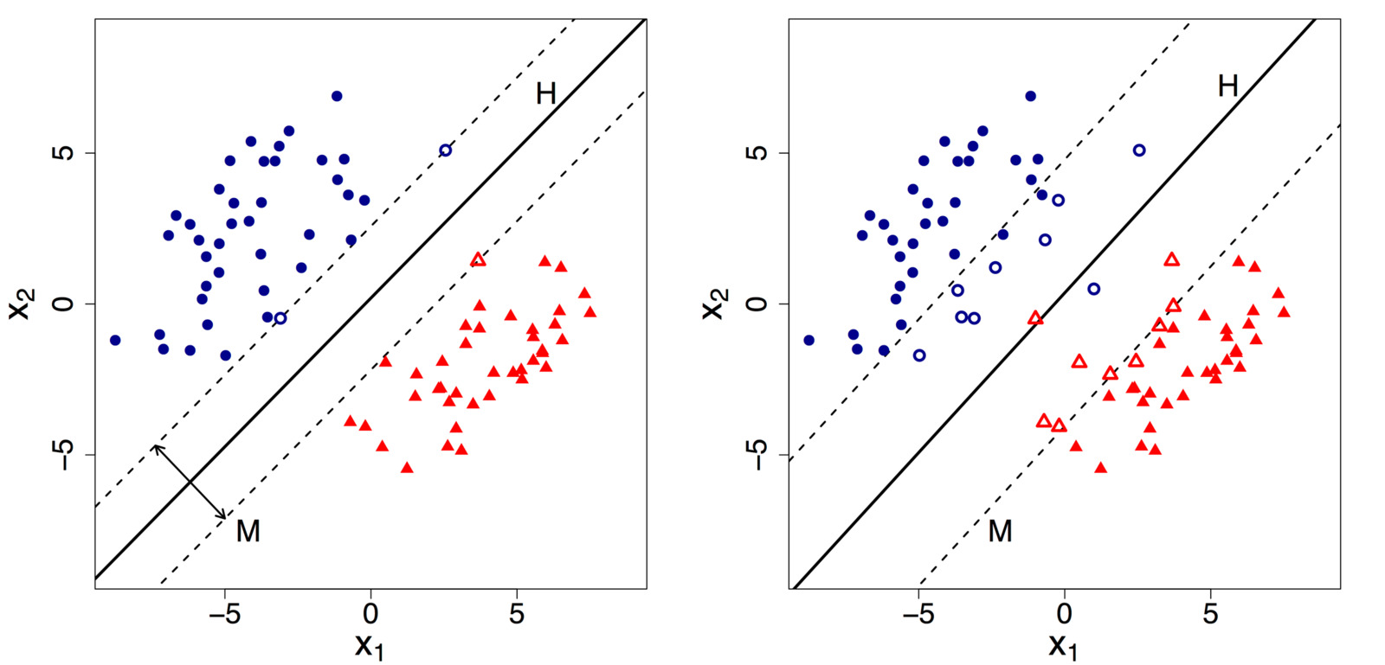
Figure 1.2
Decision rule- W.U(vectors)>=0
If it is >0 then the point is positive otherwise it is a negative point.
For Hard margin problem-
Arg-max (w*,b*) 2 / |w| such that Yi(W.Xi+b)>=1
Soft margin- if even one point either positive or negative point lies in contradictory side that is a positive point lies in negative side this is an anomaly and the hard margin problem will fail
So here soft margin will work as
Arg-min(w*,b*) |w| /2 + C∑ξi\sum \xi_i∑ξi
SVM error- Margin error + Classification error
Kernal trick
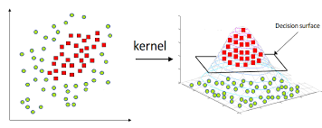
Figure 1.3
It is used to solve non linear data problems by transforming it in a 3D plane
Classification machine learning
Classification is a supervised learning technique where the model learns from labeled data and predicts a categorical (class) output e.g. yes/no , spam/not a spam etc.
For classification problems we can use SVMs,Random forest,Regression,Knn etc.
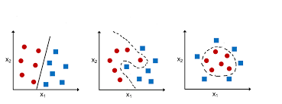
Figure 1.4
In the given figure the first graph is for SVM the second is model based learning
And the third one is for clustering (unsupervised learning)
Logistic regression
Logistic Regression is a supervised learning classification algorithm used to predict categorical outcomes, mostly for binary classes.
Logistic Regression:
- Linear Combination: Calculates a linear combination of the input features.
- Sigmoid Transformation: Applies the sigmoid (logistic) function to this result.
- Probability Output: Generates a probability value ranging from 0 to 1.
- Classification: Assigns a final class based on a set threshold, typically 0.5.
For linear model: z=wTx+b
Here x- feature vector , w-weight vector , b-bias
Prediction rule -^​={1 ​if σ(z)≥0.5 , 0 if σ(z)<0.5​}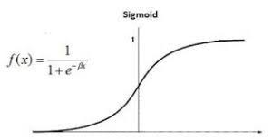
Figure 1.5
Logistic Regression creates a linear decision boundary
In 2D → straight line
In higher dimensions → hyperplane
Random Forest
Random Forest is a supervised learning algorithm that creates or build numerous decision trees and combines their results to make a final prediction.
For classification it uses majority voting for prediction.
For regression it uses average prediction.
Instead of relying on one decision tree , Random Forest:
- Trains many trees
- Each tree sees different random data
- Each split considers random subsets of features
- Combines all tree outputs = more accurate & stable
For classification: y=mode{h1(x),h2(x),.....,hn(x)}
For regression:y​=1/n∑hi​(x)

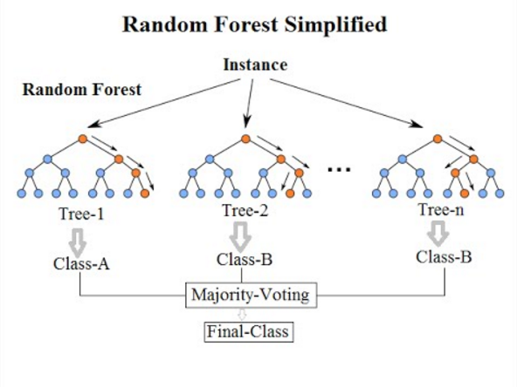
Figure 1.6
XGBOOST
In the 1970s and 1980s the early machine learning algorithms time included only the linear data models and Naive Bayes. By the 1990s more sophisticated techniques such as Random Forest, Support Vector Machines, and Gradient Boosting emerged. However, these methods faced significant challenges, including issues with overfitting and scalability. These problems consequently reduced their performance and speed, limiting their ability to effectively process large datasets.
To solve this problem, a library was designed which was made up of already existing gradient boosting techniques to increase the performance and the speed, and it was named XGBoost, which was based on machine learning and software engineering concepts.
Features of XGBoost
1.Flexibility:
- Cross platform usage- can be used in windows, linux, mac etc.
- Multiple language support:python,Java,C,ruby etc
- Integration with other library and tools
- Support all kinds of ML problems
2.Speed
- Parallel Processing: Models are built sequentially, but each individual model is trained parallelly.
- Optimized Data Structures: In XGBoost, information is stored column-wise, as columns are then done for parallel processing easily.
- Out-of-Core Computing: If a dataset is big, it is divided into chunks and then trained.
- Distributed Computing: In XGBoost, we have a feature that we can use different systems working on the same dataset, if the dataset is big.
- GPU support
3. Performance
- Regularized learning objectives: It is used when training of ML model is good but testing is not. In XGBoost there is a by default regularization
- Handling missing values: XGBoost can by default handle missing values on its own.
- Sparsity aware split finding. Automatically learns the way, the best way to handle sparse data.
- Efficient split finding(Quantile sketch plus weight approximate tree learning): it acquire speed from approximate tree learning and to improve the performance it uses weighted quantile sketch
- Tree pruning:e.g. Alpha beta pruning
The titanic dataset
The sinking of the Titanic is one of the most infamous shipwrecks in history.
On April 15, 1912, during her maiden voyage, the widely considered “unsinkable” RMS Titanic sank after colliding with an iceberg. Unfortunately, there weren’t enough lifeboats for everyone on board, resulting in the death of 1502 out of 2224 passengers and crew.While there was some element of luck involved in surviving, it seems some groups of people were more likely to survive than others.
We are going to build a predictive model that answers the question: “what sorts of people were more likely to survive?” using passenger data i.e. name, age, gender, socio-economic class, etc.
So the machine learning models that have been used are:-
- SVM
- Random forest
- Logistic regression
- Classification
- XGBoost(library)

Table 1
Measure | Mathematical Expression | Description
Accuracy | (TP + TN) / (TP + TN + FP + FN) | Accuracy measures the overall correctness of the classifier by computing the ratio of correctly classified passengers to the total number of passengers in the Titanic dataset.
Precision | TP / (TP + FP) | Precision measures how many passengers predicted as survived actually survived, indicating the reliability of positive predictions.
Recall | TP / (TP + FN) | Also known as sensitivity, recall measures the ability of the classifier to correctly identify passengers who survived.
F1-Score | 2 × (Precision × Recall) / (Precision + Recall) | The F1-score is the harmonic mean of precision and recall, providing a balanced evaluation of the classifier’s performance on the Titanic dataset.

Table 2
Model | Accuracy | Precision | Recall | F1-Score
Logistic Regression | 0.79888 | 0.77941 | 0.71621 | 0.74647
Random Forest | 0.79330 | 0.78571 | 0.63768 | 0.70400
Classification* | 0.80447 | 0.76563 | 0.71015 | 0.73684
SVM | 0.83240 | 0.83051 | 0.71015 | 0.76563
XGBoost | 0.79330 | 0.77586 | 0.65217 | 0.70866
From Table 3, it is clear that the Support Vector Machine (SVM) achieves the highest accuracy (83.24%) and F1-score (0.76563), which means it has superior overall classification performance on the Titanic dataset. Logistic Regression and the baseline classification model also perform competitively, while Random Forest and XGBoost show relatively lower recall values, suggesting reduced sensitivity in identifying surviving passengers.

